**The proteome signature of cord blood plasma with high hematopoietic stem and progenitor cell count**

Anders K Nilsson*†1, Halfdan Rydbeck*1,2, Annika Thorsell3, Sofia Frändberg4 , Helena Barreto Henriksson4,5, Camilla Hesse4, Gunnel Hellgren1,6, Pia Lundgren1, and Ann Hellström1

1. The Sahlgrenska Centre for Pediatric Ophthalmology Research, Department of Clinical Neuroscience, Institute of Neuroscience and Physiology, Sahlgrenska Academy, University of Gothenburg, Gothenburg, Sweden.
2. The Bioinformatics Core Facility at the University of Gothenburg, Gothenburg, Sweden.
3. Proteomics Core Facility at Sahlgrenska Academy, University of Gothenburg, Gothenburg, Sweden.
4. Department of Laboratory Medicine, Institute of Biomedicine, The Sahlgrenska Academy, University of Gothenburg, Gothenburg, Sweden.
5. Region Västra Götaland, Sahlgrenska University Hospital, Department of Research, development, education and innovation, Sahlgrenska University Hospital, Gothenburg, Sweden.
6. Institute of Biomedicine, Sahlgrenska Academy, University of Gothenburg, Gothenburg, Sweden.

Address correspondence to Anders K. Nilsson, [anders.k.nilsson@gu.se](mailto:anders.k.nilsson@gu.se)

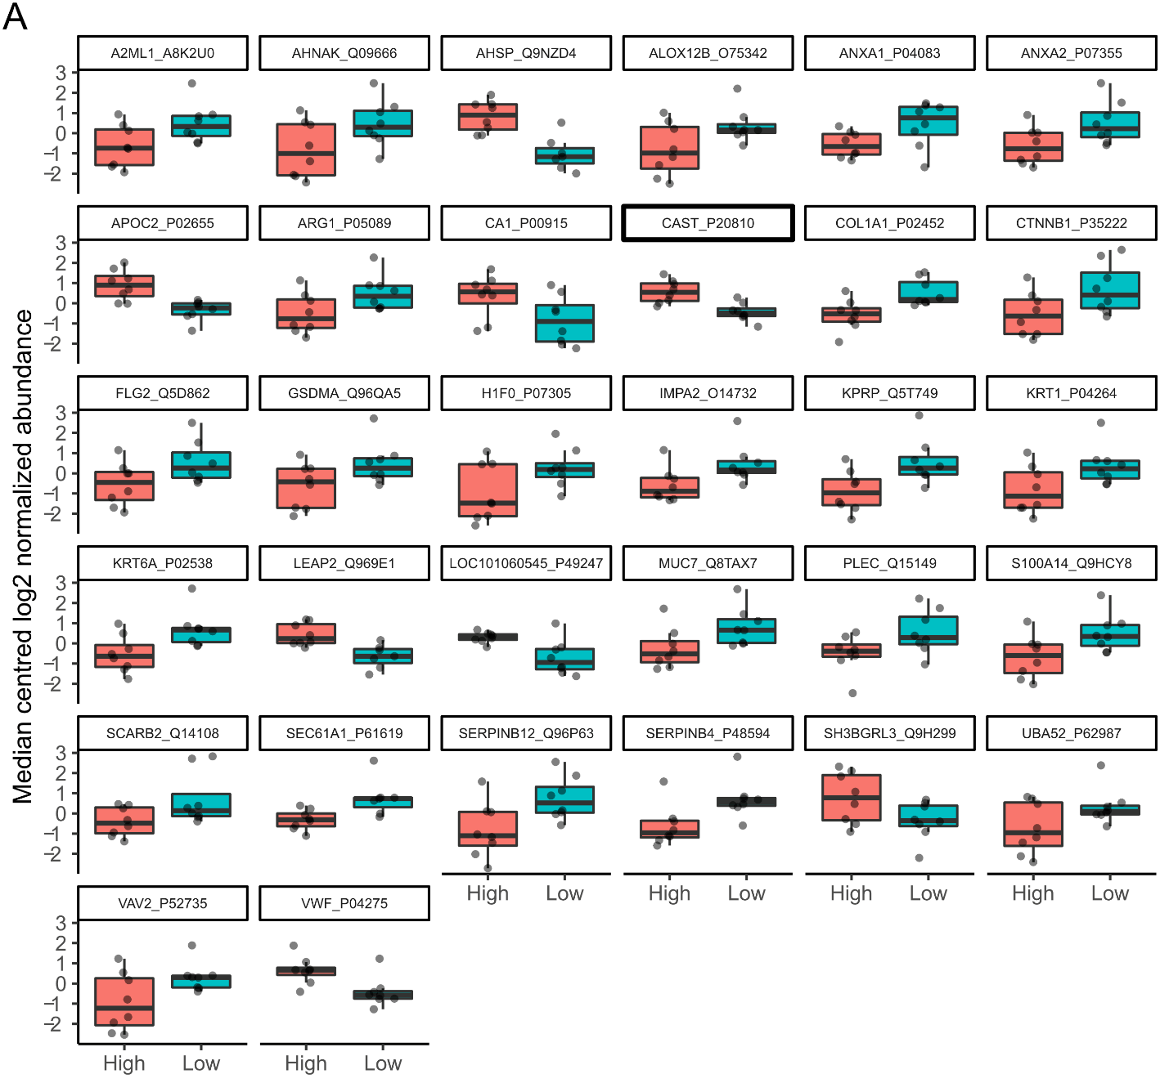

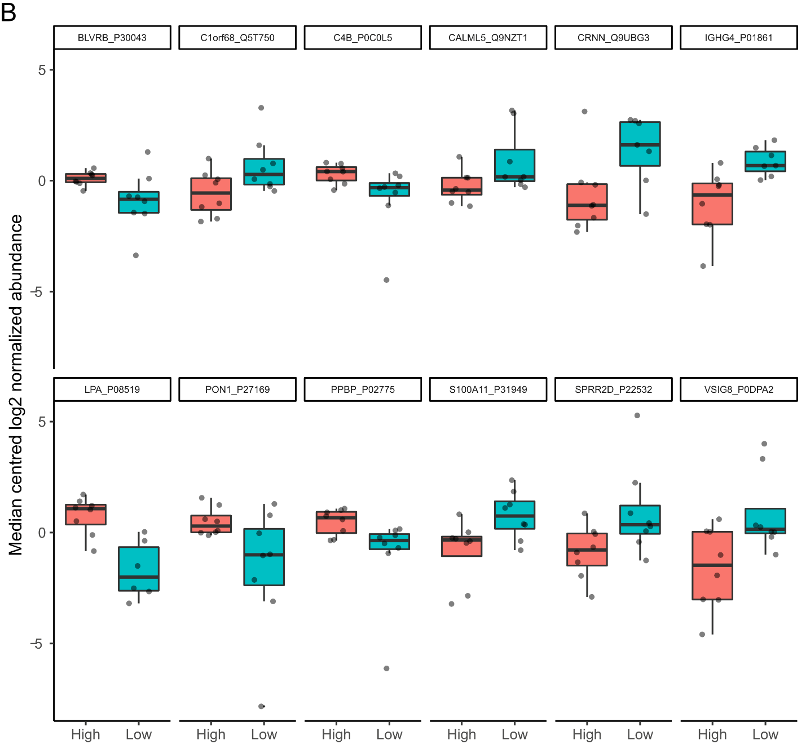

**Figure S1.** Box plots of proteins in the MS data with >two-fold abundance differences and p<0.05 between CD34+ high (red boxes) vs CD34+ low (blue boxes). **A** Proteins with narrow data distribution. **B** Proteins with wide data distribution. Raw and adjusted p-values as well as fold differences can be found in Table S2.

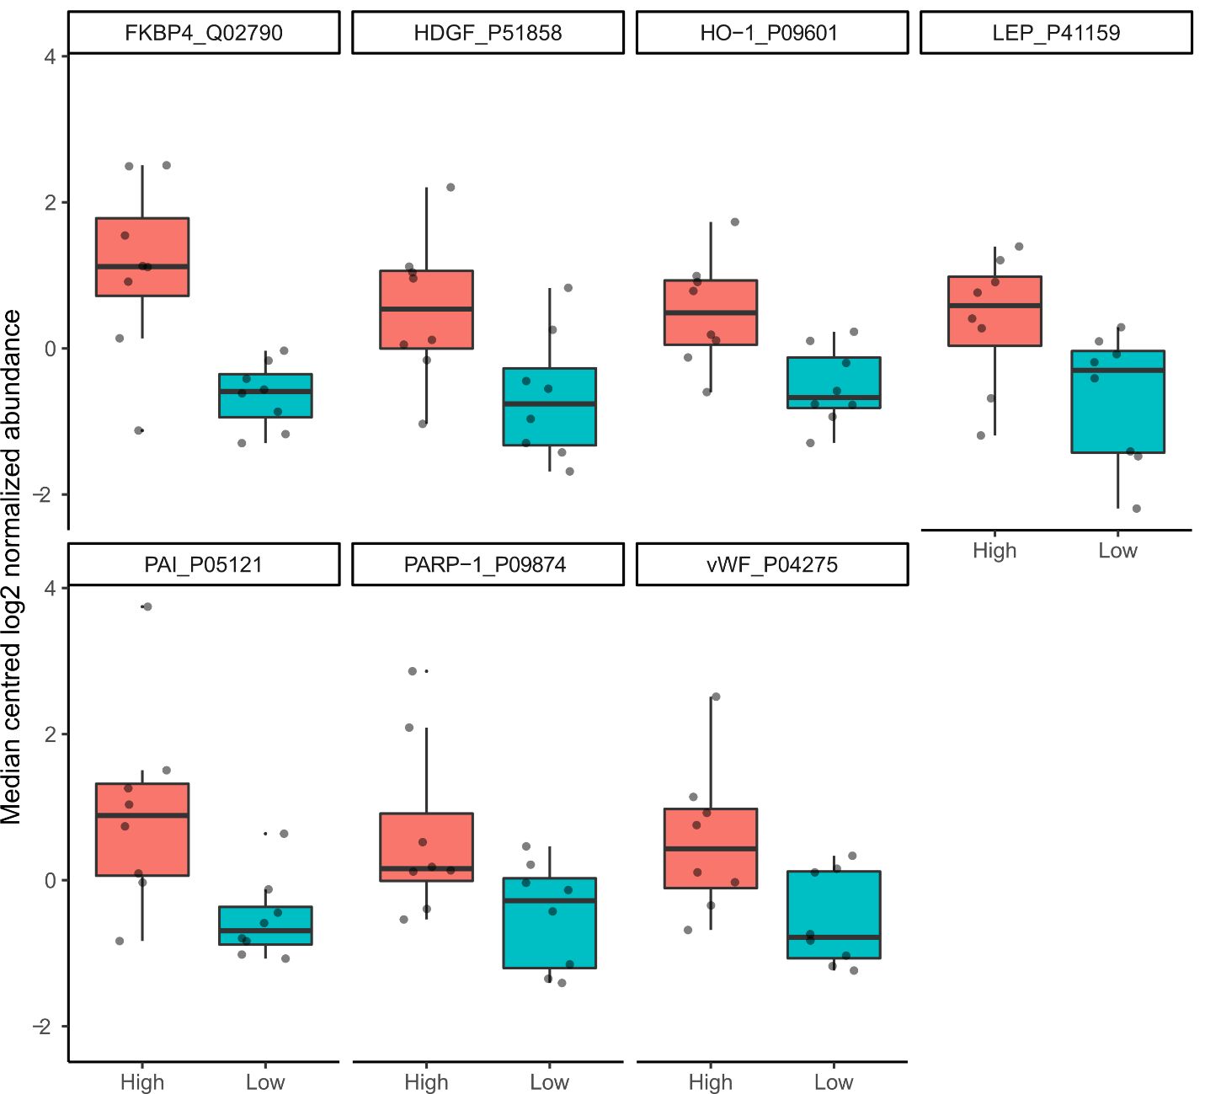

**Figure S2.** Box plots of proteins in the PEA data with >two-fold abundance differences and p<0.05 between CD34+ high (red boxes) vs CD34+ low (blue boxes). Raw and adjusted p-values as well as fold differences can be found in Table S3.

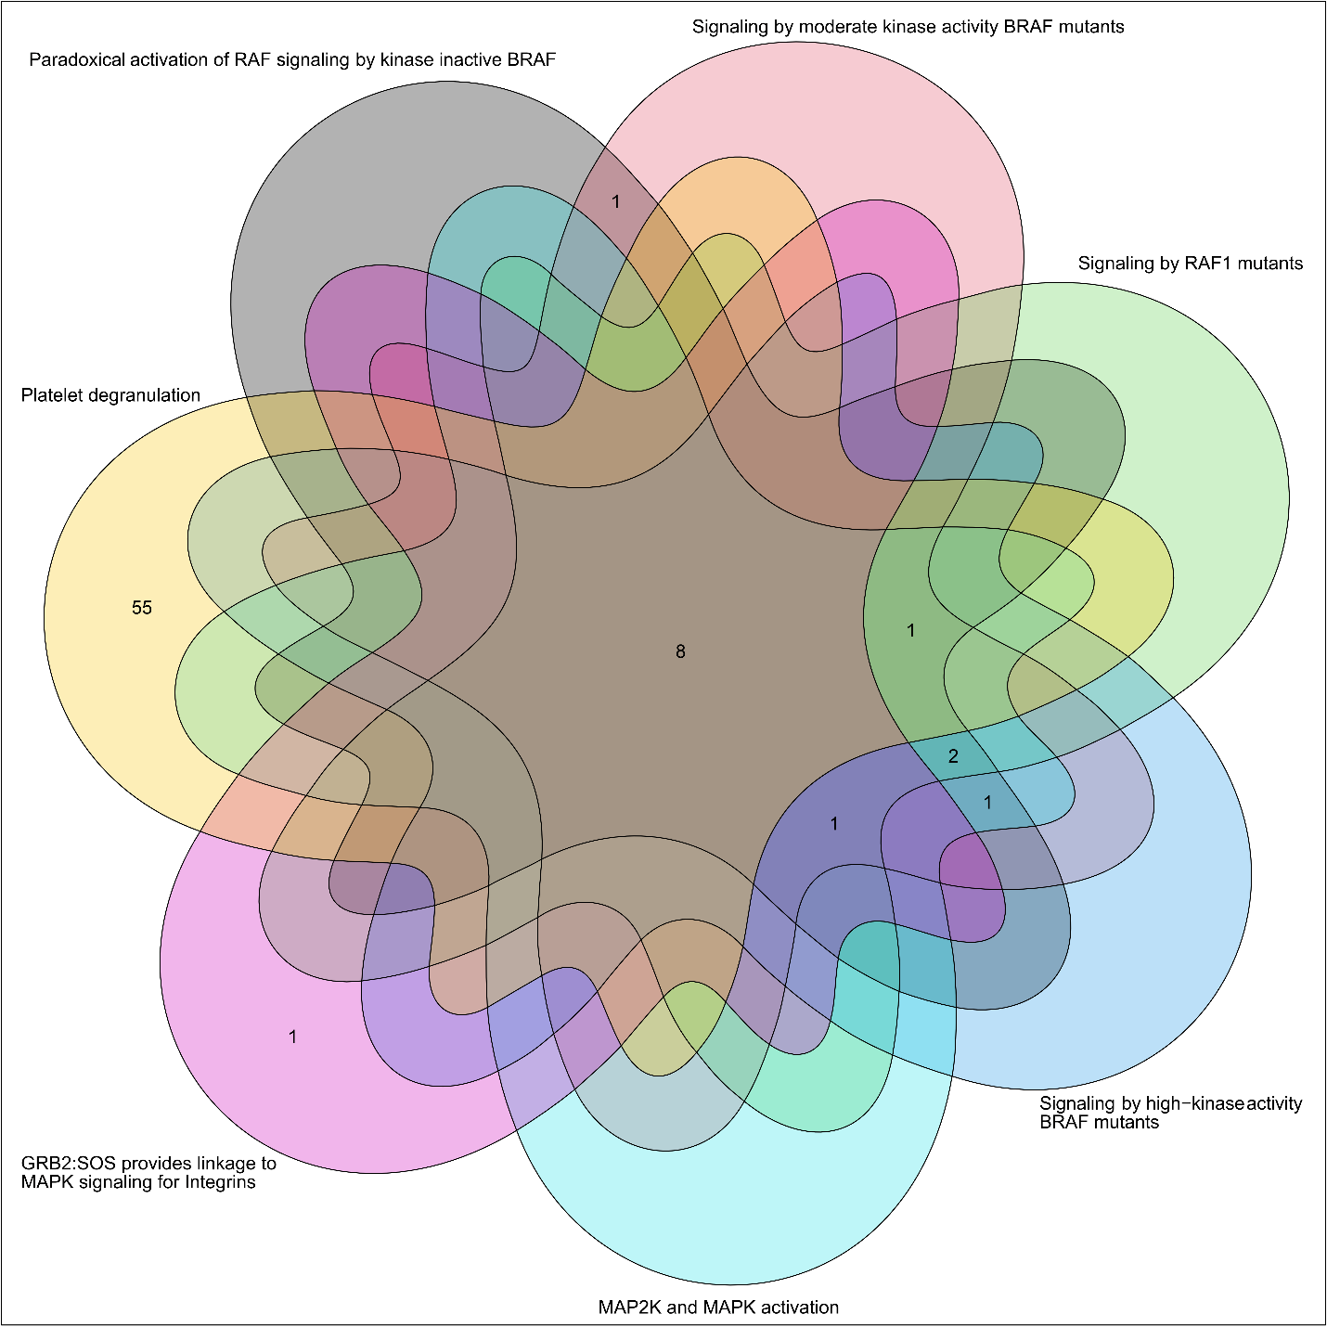

**Figure S3.** Venn diagram showing the number of shared proteins in Reactome pathways. Sub-pathways of the four branches “Oncogenic map signaling”, “Integrin signaling”, “Platelet degranulation”, and “MAP2K and MAPK activation” share 8 or more proteins. The only branch where these proteins are matching together with many other proteins is in “platelet degranulation”.

**Figure S4.** Reactome hierarchical tree for the 18 significantly enriched sub-pathways for the MS data together with “parent” pathways. Sub-pathways within each of the 7 branches share many proteins. The leading number for each significant pathway indicates the rank when ordered by p-value. The trailing numbers within parenthesis indicate the number of proteins from the MS data sets matching with the pathway and the total number of proteins within the pathway.